Stakeholder Management Strategy
LitPath AI: Smart Pathfinder for Theses and Dissertations

Asia Pacific College
3 Humabon, Magallanes
Makati City, Metro Manila 1232

April 1, 2026

Table of Contents
1. Introduction 3
2. Identify Stakeholders 3
3. Key Stakeholders 4
4. Stakeholder Analysis 5

Introduction
This Stakeholder Management Strategy outlines how we will manage the people and organizations involved in or affected by the LitPath AI: Smart Pathfinder for Theses and Dissertations project.
The main goal of this strategy is to ensure that all stakeholders, from government agency leaders and technical staff to faculty advisers and student developers, are properly identified, understood, and engaged throughout the project’s lifecycle. Effective stakeholder management helps us gain support, reduce resistance, and balance competing interests. Ignoring stakeholder needs can lead to misunderstandings, delays, or project failure.

Using this document, we will:

- Identify and classify all project stakeholders
- Determine each stakeholder’s level of power, interest, and influence
- Define how we will manage and communicate with each stakeholder group

By doing this early in initiation phase, we can:

- Gain input from influential stakeholders to guide project planning
- Minimize conflicts caused by differing objectives
- Maximize the resources, support, and cooperation needed to complete LitPath AI successfully

Early identification and open communication are critical. Some stakeholders may benefit from the project, while others may have concerns, such as budget allocation, changing requirements, system integration issues, or unfamiliar interface changes. By managing stakeholder relationships proactively, we can address these concerns early and keep the project on track.
In summary, this Stakeholder Management Strategy will help the LitPath AI project team work effectively with DOST-STII, APC faculty, student developers, and the end users, ensuring that everyone’s interests are understood and balanced as we build a smarter, faster research discovery tool for theses and dissertations.

Identify Stakeholders
The LitPath AI Project Team, consisting of student developers from APC, will conduct an internal brainstorming session to identify stakeholders for the project. This session will be based on available project documents, client communications, and faculty guidance. Because this is a Project-Based Learning (PBL) setup with limited direct access to DOST-STII personnel, the initial stakeholder identification will be done by the developer team. The session will be divided into two parts. The first part will focus on internal stakeholders within APC, including student project developers and SoCIT project advisers. The second part will focus on external stakeholders outside APC, which may include DOST-STII (Science Research Specialists) and end users of the research discovery tool.
Once the developer team has completed its initial stakeholder list, the list will be reviewed and validated by the project advisers to ensure completeness and accuracy. If any stakeholders were missed, they will be added at this validation step. Furthermore, if new stakeholders emerge during the project lifecycle, they will be added and managed accordingly. Based on actual project interactions, additional DOST-STII personnel such as a technical specialist, the head librarian, or the department head may occasionally attend meetings and should be considered stakeholders if they meet the criteria below.

To decide whether a person or organization should be considered a stakeholder, the project team will ask five questions.
- Will the person or organization be directly or indirectly affected by this project?
- Does the person or organization hold a position from which they can influence the project?
- Does the person have an impact on the project's resources, including material, personnel, or funding?
- Does the person or organization have any special skills or capabilities the project will require?
- Does the person potentially benefit from the project, or are they in a position to resist this change?
Any individual or organization that meets one or more of these criteria will be identified as a stakeholder.

Key Stakeholders
For the LitPath AI project, the following stakeholders have been identified as key stakeholders. From DOST-STII, Assistant Secretary Napoleon K. Juanillo, Jr. PhD is a key stakeholder because he has high influence over budget allocations and project approval. The two Science Research Specialists, Khasian Eunice Romulo (Primary POC) and Jonathan Abalon (Alternate POC), are key stakeholders because they define requirements, approve deliverables, communicate with the Office of the Solicitor General, and have direct influence over project success.
From APC, the PBL Coordinator Manuel Sebastian S. Sanchez is a key stakeholder because he sources projects and manages the partnership with DOST-STII. The SoCIT Faculty or Project Advisers are key stakeholders because they provide project guidance, technical mentorship, approve deliverables, and evaluate academic outcomes. The student developers are also key stakeholders because they are directly responsible for system development and project delivery. The end user is not considered a key stakeholder for the purposes of intensive management but will be kept informed as users.

Stakeholder Analysis
Once all LitPath AI stakeholders have been identified, the project team will categorize and analyze each stakeholder. The purpose of this analysis is to determine the stakeholders' level of power or influence, plan the management approach for each stakeholder, and to determine the appropriate levels of communication and participation each stakeholder will have on the project.
The project team will categorize stakeholders based on their organization or department. Once all stakeholders have been categorized, the project team will utilize a power and interest matrix to illustrate the potential impact each stakeholder may have on the project. Based on this analysis the project team will also complete a stakeholder analysis matrix which illustrates the concerns, level of involvement, and management strategy for each stakeholder.

The chart below will be used to establish stakeholders and their levels of power and interest for use on the power and interest chart as part of the stakeholder analysis.

Key | Organization | Name | Power (1-5) | Interest (1-5)
A | DOST-STII | Assistant Secretary Napoleon K. Juanillo, Jr. PhD | 5 | 3
B | DOST-STII | Science Research Specialist II - Khasian Eunice Romulo (Primary POC) | 4 | 5
C | DOST-STII | Science Research Specialist II - Jonathan Abalon (Alternate POC) | 4 | 5
D | APC | PBL Coordinator - Manuel Sebastian S. Sanchez | 3 | 4
E | APC | SoCIT Faculty / Project Advisers | 3 | 5
F | APC | Student Developers | 2 | 5
G | External | End Users | 1 | 4

Below is the power and interest chart for the LitPath AI stakeholders. Each letter represents a stakeholder in accordance with the key in the chart above.

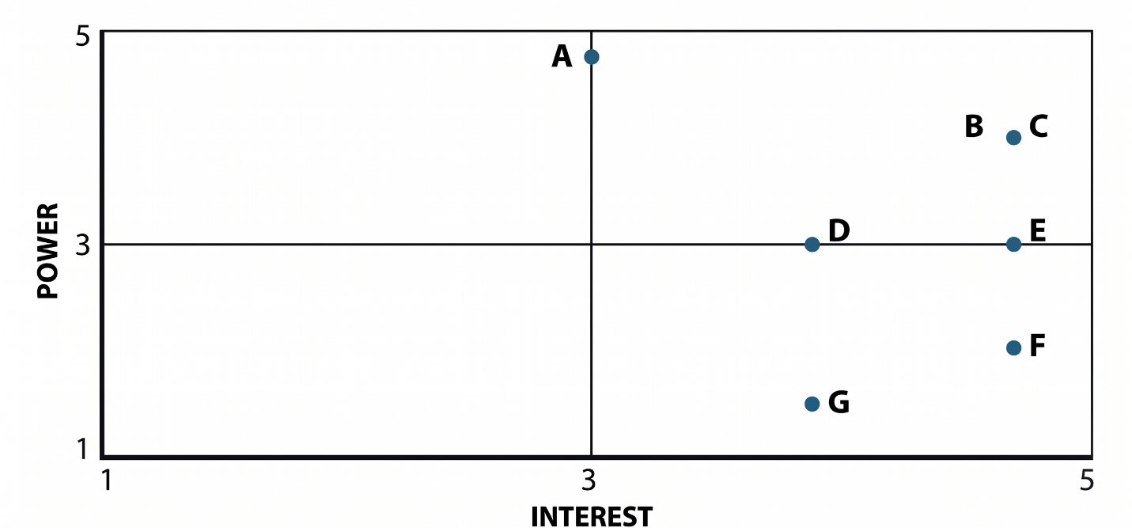

POWER: Refers to a stakeholder's level of direct or indirect influence and authority over project decisions, resources, and final outcomes.
INTEREST: Refers to the degree of importance or priority a stakeholder places on the project's goals, deliverables, and success, which affects their desire to be involved.

Quadrant Descriptions:
- Manage Closely (High Power, High Interest): (B, C) These stakeholders are critical for success and require maximum attention and active engagement to understand and satisfy their needs.
- Keep Satisfied (High Power, Low/Mid Interest): (A) These stakeholders have significant authority but lower engagement. Keep them content with major milestones and decisions to prevent them from becoming impediments.
- Keep Informed (Low Power, High Interest): (D, E, F, G) These stakeholders are highly invested in the outcome but have limited influence. Regular updates and opportunities for input are key to maintaining their support and managing their expectations.
- Monitor (Low Power, Low/Mid Interest): (Empty) These stakeholders have minimal interest and minimal impact. Monitor them for any changes in their position or status with minimal effort.

The stakeholder analysis matrix will be used to capture stakeholder concerns, level of involvement, and management strategy based on the stakeholder analysis and power and interest matrix above. The stakeholder analysis matrix will be reviewed and updated throughout the project's duration to capture any new concerns or stakeholder management strategy efforts.

Sponsor Acceptance

Approved by the Project Sponsor:

Date: April 1, 2026
Khasian Eunice Romulo
Science Research Specialist II / Unit Head
(Digital Information and Processing Delivery Unit)

